Job Billing overview

Overview
This document outlines the job billing process with focus on the data model and how it works.

Initial Job Setup

Creating the Job and orders.

Everything starts with a Job costing document and all Job billing is for Jobs not opportunities and requires at least one sales order.
Job billing itself works off the Opportunities tab. You are not required to setup the records first; you can create a sales order to that job and the system will auto sync them. In this example there will be 2 orders with lines for windows and doors.
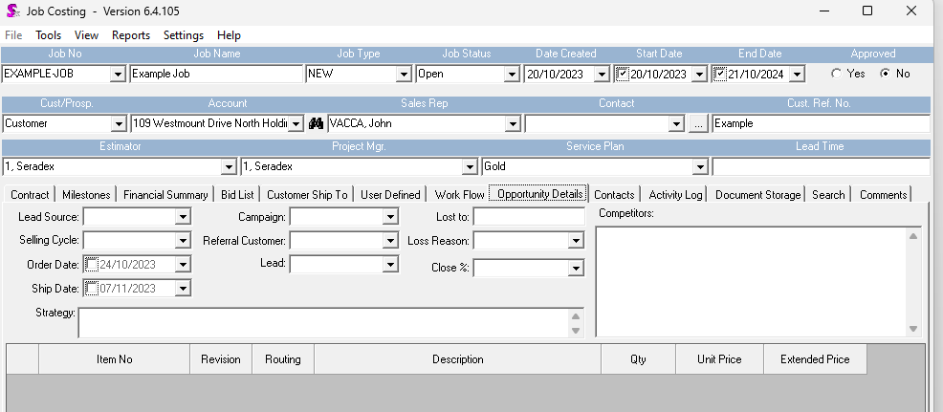
The opp details are kept in sync with the orders.
For example, you can create right from Job costing, or setup the opp details first then generate SO from Job or manually make up an order and tag it yourself.
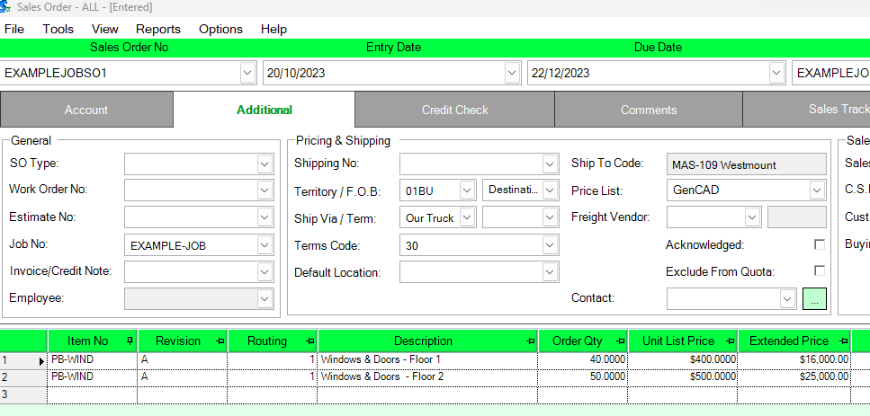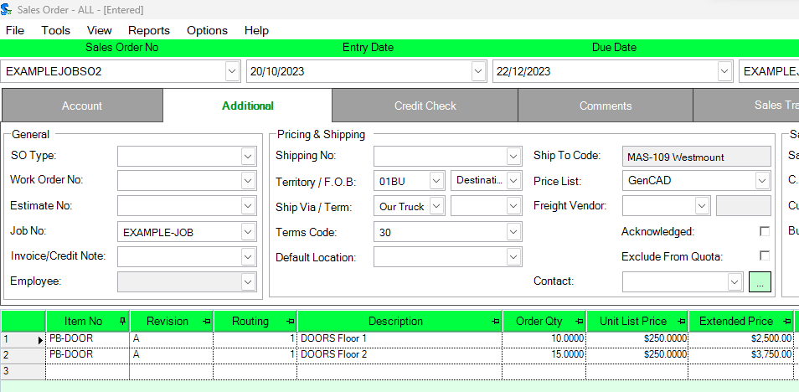
The sales order will auto sync the opp details on the job:
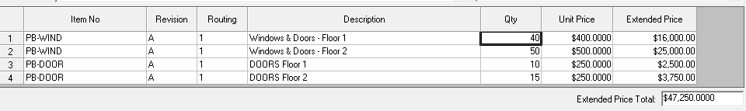
One opp detail can exist on a quote however will be moved to the sales order line once generated. One opp detail can only ever exist on one sales order line. This concept is important for later sections.
At this stage the user is setting up what is known as the “original Contract” this is defined in our system as the total of all sales order assigned to the Job at the time of approval.
Using the above example, if the amounts are agreed upon, the job is ready to be approved.
At this stage the JobControlOppDetails Table has the following data, note only fields relevant for job Billing are shown, it is noted that these fields match the sales order lines.
JobControlOppDetailID | JobControlMainID | QtyOrdered | Description | ItemNo | UnitPrice | ExtendedPrice | Inactive
277589 | 2508 | 40 | Windows & Doors - Floor 1 | PB-WIND | 400 | 16000 | 0
277590 | 2508 | 50 | Windows & Doors - Floor 2 | PB-WIND | 500 | 25000 | 0
277591 | 2508 | 10 | DOORS Floor 1 | PB-DOOR | 250 | 2500 | 0
277592 | 2508 | 15 | DOORS Floor 2 | PB-DOOR | 250 | 3750 | 0

Each of the JobCotrolOppDetailID above is bound to the relevant sales order detail ID field on the orders against the Job.
The original contract amount has to be tracked and preserved no matter what future changes to any order may be.

Setup of Description of work.
The next step is the setup of the “Description of work” which is also known as the Schedule of values, there are many third party programs and do this kind of billing and I have seen both.
It is really between the end customer and the user setting up the job to know how these are setup as it can vary by job, there is no rule that says one SO has to be one schedule of value in fact mulitiple orders can all be on one or spread out over many. Even one order can be on multiple.
Here is a great explanation from an online tutorial aimed at the construction industry.
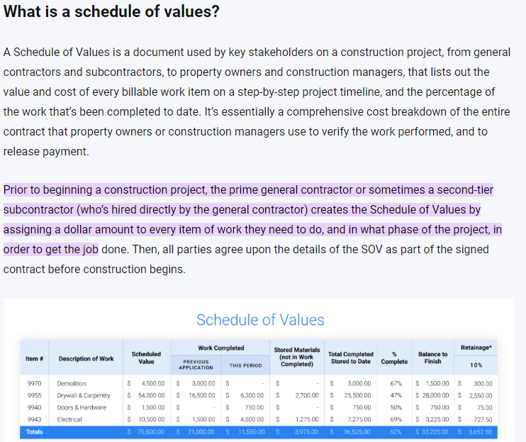
In our system you are required to setup these and every sales order line must be accounted for before you can consider the job approved and locked down.
Using the example order, the end user wants to be billed by the Floor and does not wish to break out window and doors.
Therefore within Job costing you go to the Description of work setup in the tools menu.
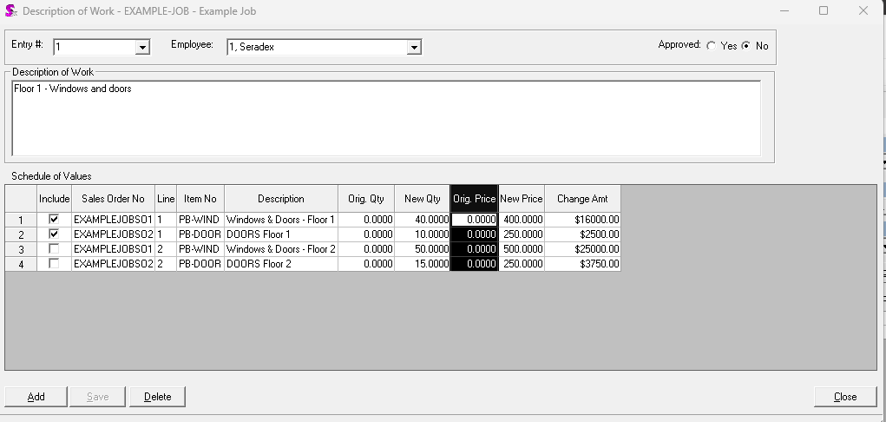
This is the first one so here we pick the first two lines as they happen to be for what the end user wants to be billed. You will notice that everything appears and we select what we want.
The original qty and price are zero as these are new lines never before captured on a description of work. This becomes more important when change orders are discussed.
To be considered for billing, the schedule of value must be approved. Unapproved schedule of values are considered in progress and not yet finalized. The end user has to approve of the schedule in some cases.
I complete by capturing the rest as follows
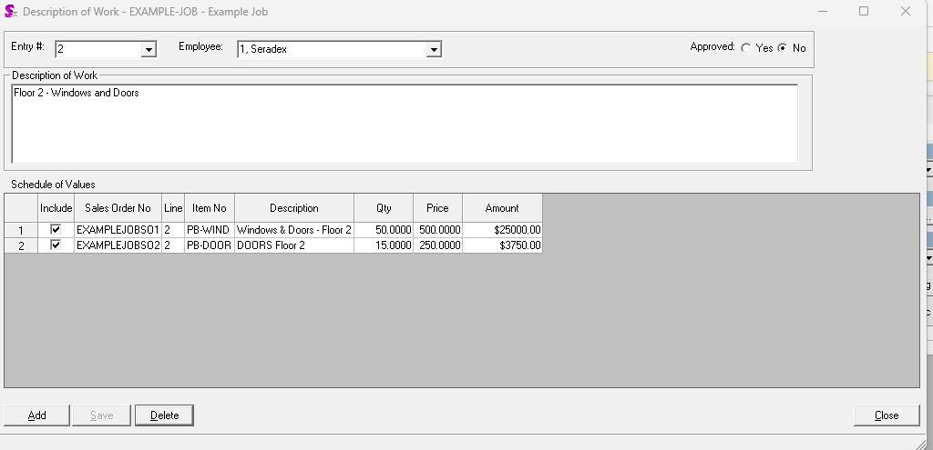

This time only two records appear as the system knows the others are captured.
After approval above the data model appears as follows
JobControlBillingID | LineNo | JobControlMainID | ChangeOrder | EntryDate | Description | Amount | Employee  ID | Approved | HeldRetentionRatio
3332 | 1 | 2508 | 0 | 2023-10-20 | Floor 1 - Windows and doors | 18500 | 160 | 1 | NULL
3333 | 2 | 2508 | 0 | 2023-10-20 | Floor 2 - Windows and Doors | 28750 | 160 | 1 | NULL

This is the job control Billing table, there is one per description of work always, the amount is the total dollar amount. Since this is before approval, Change order is false. The entry date is always current date and change order is always handled by the system. It is not possible for a user to decide right now what is a change order or not.
The JobControlBillingID field is the link to the description of work.
For the details the data is stored as follows for the above:
JobControlBillingOppDetailID | JobControlBillingID | JobControlOppDetailID | OriginalQty | NewQty | OriginalUnitPrice | NewUnitPrice | Amount
159973 | 3332 | 277589 | 0 | 40 | 0 | 400 | 16000
159974 | 3332 | 277591 | 0 | 10 | 0 | 250 | 2500
159975 | 3333 | 277590 | 0 | 50 | 0 | 500 | 25000
159976 | 3333 | 277592 | 0 | 15 | 0 | 250 | 3750

You will note that the original Qty and original prices are zero.

Approval of the Job and progress setup with retention.

Now the job can be approved which means from this point forward without unapproval, the original contract is locked in at the sum of the existing descriptions of work and cannot change.
The final setup is the Progress payment setup, this was the old method of doing job billing which predated the new way by a few years.
This is where you setup the items which the system auto fills in most cases and where you setup retention.
Retention is something that is up to the user entering the job and the actual end user who is paying for it. While there is no hard rule about when to use it or what rate, it is fairly common to use 10%.
Here is a great explanation of it from another third party application, https://www.knowify.com/docs/submit-retainage-invoice-aia-format/
Retention billing will be discussed further as there is quite a bit of logic involved.
In job costing go to setup progress payments.
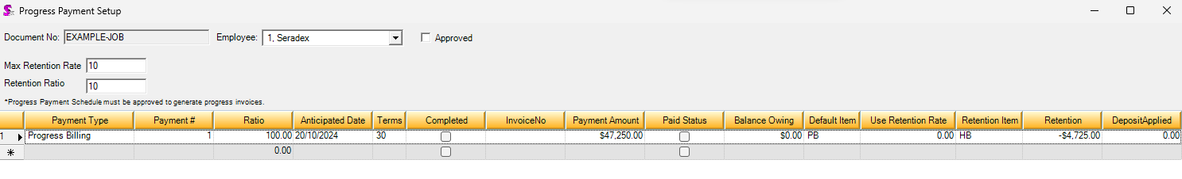
Now this form you only need the one record as the job billing logic for invoices manages the rest, the Default item is the same logic as SO based deposits, looks for any non tracked item against the category you setup against the “Deferred Revenue” category type. Retention item is separate and is the same setup as the deposit item but looks for the “Job retention” category type on the category.
In the above example I am using the typical 10%, the ratio does not matter in the setup, the logic later on manages it all for you. This form mainly is where you setup the initial retention ratio and the items to use on the invoices.
Once approved you can start billing and each detail record will eventually map to an invoice.

Change orders

Change orders are defined as any change that raises or lowers the overall job total after the original contract.
These include the following, all which are done after job approval and may or may not have any billing yet. Yes the job can be unapproved but this situation is when the contract is already set.
These changes are when there is already a description of work too on the order line.
Changing a line qty and/or the unit price, even discounts, by any means.
Adding a new line to an existing order or adding a whole new order.
Deleting an existing order line.
Deleting an entire order.
The only time a change order could exist with zero order price change at all is cancelling a line, this is a unique situation which is outlined in the change order section.
It is important to note changes orders do not exist in the system until the user sets them up, change orders still have to be agreed upon.
Using the above example, the contract is agreed upon and the first floor they decide to go with a window that costs $50 more and wants on the second floor a $1500 railing.
The user decides to update the first order to add 50 per unit and does a whole new Sales order to the job for the $1500 railing.
This means so far costs went by $3500 overall.
Since the system syncs the opp details, the job now appears as follows:
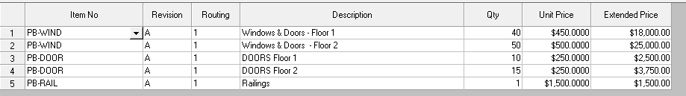

In this situation the end user wants it as one change order, but that is not a hard rule, could be considered 2 but the process is the exact same.
To create the change order, you go back into the description of work form and press Add. The system uses the JobControlOppDetails table as it is now and compares to all prior descriptions of work to figure out the differences.
Using the above data the form knows to derive the change order like this:
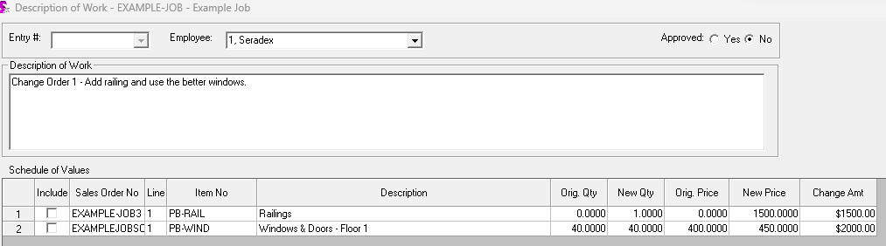
You can see how it takes the opp details as they are in the data now and compares to the prior JobControlBillingOppDetails records.
The above tells us the railing order line is new as the original qty and price is zero to arrive at 1500 and the price went from 400 to 450 to arrive at 2000.
The existing JobControlBillingOppDetails records are follows at this point
JobControlBillingOppDetailID | JobControlBillingID | JobControlOppDetailID | OriginalQty | NewQty | OriginalUnitPrice | NewUnitPrice | Amount
159973 | 3332 | 277589 | 0 | 40 | 0 | 400 | 16000
159974 | 3332 | 277591 | 0 | 10 | 0 | 250 | 2500
159975 | 3333 | 277590 | 0 | 50 | 0 | 500 | 25000
159976 | 3333 | 277592 | 0 | 15 | 0 | 250 | 3750

The existing opp details are as follows
JobControlOppDetailID | JobControlMainID | QtyOrdered | Description | ItemNo | UnitPrice | ExtendedPrice | Inactive
277589 | 2508 | 40 | Windows & Doors - Floor 1 | PB-WIND | 450 | 18000 | 0
277590 | 2508 | 50 | Windows & Doors - Floor 2 | PB-WIND | 500 | 25000 | 0
277591 | 2508 | 10 | DOORS Floor 1 | PB-DOOR | 250 | 2500 | 0
277592 | 2508 | 15 | DOORS Floor 2 | PB-DOOR | 250 | 3750 | 0
277596 | 2508 | 1 | Railings | PB-RAIL | 1500 | 1500 | 0

You can see JobControlOppdetailID 277589 now says 450 but adding up the prior you see it was 400 before so that is how we know the qty is the same but the price went up by 50.
Records 277590 to 277592 have not changed therefore they are not even picked up and the last one is not recorded at all so that is how we know it is new.
Upon save a new record is injected into JobControlBilling and you will see the change order flag is true.
JobControlBillingID | LineNo | JobControlMainID | ChangeOrder | EntryDate | Description | Amount | EmployeeID | Approved
3335 | 3 | 2508 | 1 | 2023-10-20 | Change Order 1 - Add railing and use the better windows. | 3500 | 160 | 1

And the details are as follows:
JobControlBillingOppDetailID | JobControlBilling  ID | JobControlOppDetailID | Original Qty | New Qty | Original UnitPrice | New UnitPrice | Amount
159978 | 3335 | 277589 | 40 | 40 | 400 | 450 | 2000
159979 | 3335 | 277596 | 0 | 1 | 0 | 1500 | 1500

Deleted lines are still recorded even if the sales order is gone. It is important to note that a change order can be negative and legitimate, zero-dollar ones are legitimate.
For example, most Microvellum clients have the concept of a billing order which does not have to be real item tracked items, it just is there for pricing to feed this. The real items being made and shipped are on a zero-dollar sales order. That is all perfectly acceptable, the end user does not get billed by those orders, everything is through this. You can see the one sales order line already is on two separate descriptions of work.

Invoicing

First invoice

Invoicing itself is really just a deposit invoice generation tool, they are not bound to the sales order directly and just for the job.
Also, there is no rule that says you even have to have a single shipment done, one example I was given from a client is the Project manager uses information to anticipate what to bill and will do so days before the real shipment.
As everything with this module, invoices even need to be approved by the end client. Disputes can and will happen. You are allowed to even bill more as long as everyone agrees on it. We cannot 100% state to someone what values they should bill only they can know that.
The UI presented when you go to generate Billing uses all the data so far to work out the data to show. The reports use this identical logic.
The header section shows all the current job values, since this is the first billing some data will be zero.
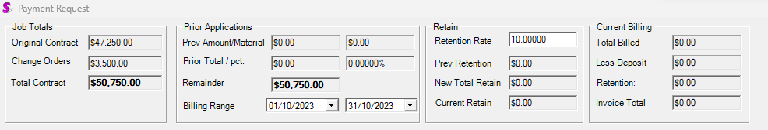
Here you can see the original value which is just the sum of the JobControlBilling records not flagged as change order.
Then you see the change orders and the total is always the sum of the two.
Since this is the first billing, Prior is all zero.
Retention defaults as that is what we setup during the original job creation phase.
Current billing is zero as you have not done anything yet.
The next section shows the high level descriptions of work and their billing status.
Here you can see how it matches the JobcontrolBilling table. The Shipped amount and pending order amount here are a calculated field, it just is based on the recent shipments and any order that may be due by month end. Billing is usually a monthly process. The user does not need to use those values, just there to give them information.
Here all the previous values are zero because this is the first billing.
Clicking on each line shows the breakout to the order level.
To actually bill, there are many ways users can do it, all legitimate.
Some will work out a ratio, say this time you feel 40% of the floor one is done, now the description of work can say anything, can say things like phase 2 or whatever.
So if you decide to use 40% you can enter in current billing. You can also decide to enter on the break out to pick and choose which billing detail to bill. All data entered in the header rolls down to the details and any detail change rolls up. The actual invoicing and all reports is based on the high level description of work always.
However here is what the data shows when I do 40% of the first record.
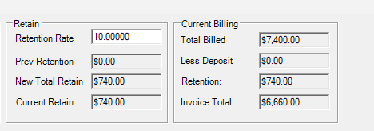
The high level record shows:
And the details of line 1 shows this
So you can see the 7400 at the top is the sum of the current billings on all the top lines which in turn is the sum of all the details.
Retention you can see is 10% of this current billing leaving us with an invoice amount of 6660.00
Retention is calculated to mean the total retention billed is equal to 10% of all prior billings plus this one.
Once you save, no invoice is generated. You can leave this form and come back later. This state is the pending billing, it means you have it setup but no actual invoice exists.
This generates the next set of tables with drives the entire billing process.
The first table is JobControlProgressTracking, there is always one per billing.
Here is the exact data from the above
JobControlProgressTrackingID | JobControlBillingID | ProgressPaymentDetailID | Amount | MaterialAmount | RetentionAmount
4654 | 3332 | 3193 | 7400 | 0 | -740

Here you can see what Job control billings I billed, exactly how much in total and exactly how much the total retention was. The progress payment detail ID here is assigned to the progress payment we setup during the initial phase. That is why it was stated the ratio does not matter; this logic manages it all for you. There is only one record as we only touched one description of work. If we billed more than one you get two records.
There is also a detail table which is the real tracking against the JobControlBillingDetails
For this it looks like this
JobControlProgressTrackingDetailID | JobControlProgressTrackingID | JobControlBillingOppDetailID | Amount | MaterialAmount
7173 | 4654 | 159973 | 6400 | 0
7174 | 4654 | 159974 | 1000 | 0

Here you can see how it backs up, we now know on this billing you billed this exact amount against the detail description of work. And all this data is used to know how much is left to bill.
A job can have many billings spanning months or years and all this data is kept to track it all and let you work out what the billing to date would have been in the past.
We now make an invoice, which is really just a job level deposit invoice. To accounting this is no different than any other AR invoice. The end customer only pays this and does not care about anything else. Invoices for real shipments are irrelevant.
However the invoice is generated a special way.
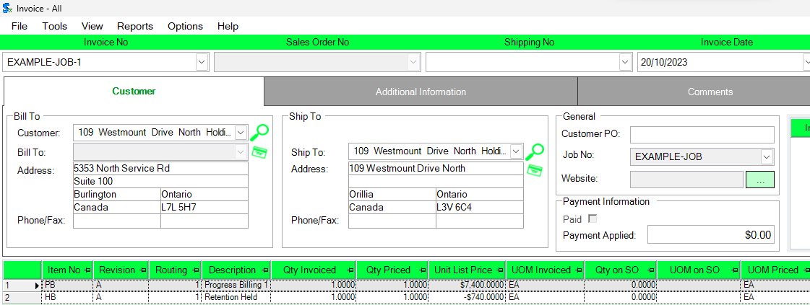
You will see there is one line per description of work, there is no link here to any sales order.
The progress payment detail now appears like this
ProgressPaymentDetailID | Progress  PaymentID | Task  No | Ratio | DueDate | Completed | InvoiceID | Next  Task | Invoice  Amount | Retention  UtilizeRatio | Retention  Amount
3193 | 1444 | 1 | 14.58128079 | 2024-10-20 | 1 | 26649 | NULL | 7400 | 0 | -740
So you can see it all ties together, I can tell exactly what was billed and what invoice it is. This is how all the reports work.
The invoice number no matter what you do is based on the Job number. You can edit things like the line description if you want but the pricing is off limits.
It is important to understand that tax may be added but you do not see it anywhere in the billing. This is normal.
Now typically this is not even paid until the end user actually agrees with it. You can delete this invoice and edit the billing and redo which updates all the tracking tables.
The end user does not care about the real invoices only these.
After invoice is generated, you can see the whole billing screen changes as now we have prior billing data to read.
The header now shows
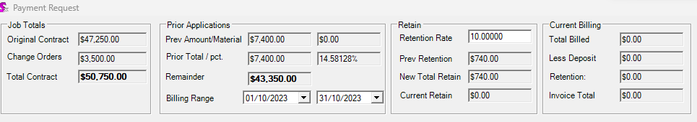
You can see the prior applications updated which is the sum of the prior billing and as each invoice is done that total is the sum of all billings before that.
Retention shows how much we billed so far and we are left with the remainder.
The description of work line is updated to match exactly the last invoice
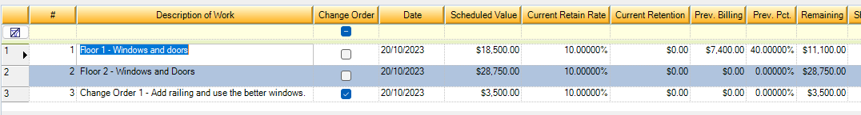
It does not matter how many invoices you actually do; we must track all the prior invoices and exactly what you billed. You must eventually bill 100% of everything and cannot bill on cent more or less.
That is the real purpose of the job tracking tables.

Subsequent Invoices

Let’s assume the first invoice is fine and we want to bill the bulk of the next phase, everything but the railing. The system manages the progress payment details for you and at this stage a second detail is created. The system uses that record to work out the prior by simply adding up all the dollar amounts on all prior progress payment details and links that to the relevant JobControlProgressTracking and JobControlProgressTrackingDetails tables.
No ratios are stored it is always dollar amount.
Billing everything but the railing, the header now looks like this:
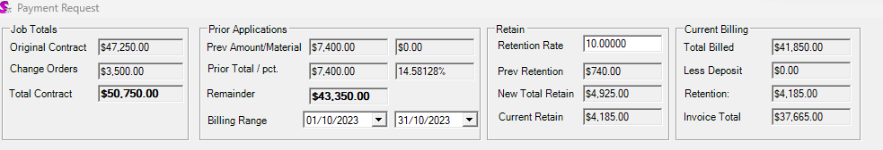
Retention is still 10% and you can see how it works is it takes the total prior billings, adds in this pending billing to arrive at the 49250.00 to date total. Retention is always on the total unless detail level is used, therefore the system expects 4,925 and since 740 was billed before that is why the retention is 4,185. It actually is not 10% of the current billing, this case it happens to be that way but will be explained in the section pertaining to retention reclamation/adjustments. Detail level is explained as well.
The schedule value sections now appear as the following:
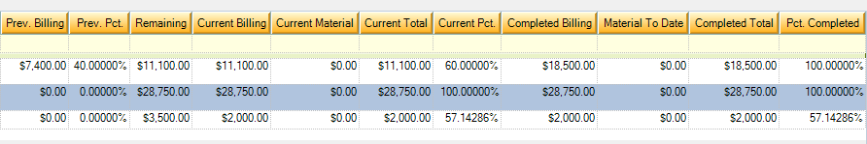
You can see it knows the 7400 is for that first description of work because of the prior JobControltrackingDetails points to that record and recorded 7400. You will note that the current pct is now different than the Pct completed. This is because the current pct represents the ratio of the current billing which here is 60% of the total and the pct Completed is based on the current plus all prior billings.
The user actually can enter in current pct or current billing as a dollar amount, or they can instead use the total Pct completed. This case you can say I am billing 60% of the overall total this billing or state I want to bill enough to make the whole description of work 100%. This logic works on the details as well which roll up.
Once you save, the system once again creates the tracking records.
JobControlProgressTrackingID | JobControlBillingID | ProgressPaymentDetailID | Amount | MaterialAmount | RetentionAmount
4654 | 3332 | 3193 | 7400 | 0 | -740
4655 | 3332 | 3194 | 11100 | 0 | -1110
4656 | 3333 | 3194 | 28750 | 0 | -2875
4657 | 3335 | 3194 | 2000 | 0 | -200

The first record is from the prior billing and three new records are added because we touched this time 3 descriptions of work. You can see the current billing dollar amount is stored like before and retention is also a dollar amount. No ratios are actually stored, they are all calculated.
JobControlProgressTrackingDetailID | JobControlProgressTrackingID | JobControlBillingOppDetailID | Amount | MaterialAmount
7173 | 4654 | 159973 | 6400 | 0
7174 | 4654 | 159974 | 1000 | 0
7175 | 4655 | 159973 | 9600 | 0
7176 | 4657 | 159978 | 2000 | 0
7177 | 4656 | 159975 | 25000 | 0
7178 | 4655 | 159974 | 1500 | 0
7179 | 4656 | 159976 | 3750 | 0
The details show which JobControlBillingOppDetailID was touched, which in turn links back to the sales order line. This data is how the system knows how much is billed. Deleted sales order lines still show up if you had them as part of the original contract or on an approved change order.
The above produces the following invoice data
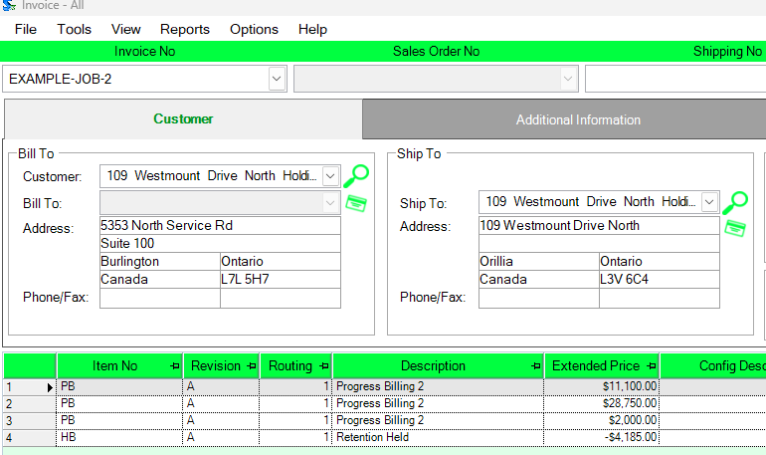
You can see its one invoice line per description of work and one for retention, all based on the dollar amounts on the current billing.

Retention and Final Billings

Up to this point retention was held back by the customer and can be held back until the Job is done, or until an agreed upon stage in the Job. It is typically between 5 and 10 percent and the system allows it to be adjusted at any point.
Our system works like many other third party Constuction and project billing applcaitons.
Here is a great explanation of what retention really is from another application which is exactly how ours is done.
“Retainage is an amount of money earned but held back from payment by a General Contractor or Owner until the end of the job (or some other time specified in the contract). Retainage is meant to serve as an insurance policy in case some of the work performed is not of sufficient quality, or if the scope of work performed does not match the scope provided in the contractor’s bid.
A standard value for retainage is 10%. If you’re a subcontractor, please make sure you negotiate retainage carefully! It can be very hard to get prompt release of your retainage (which is rightfully your money) after a job ends; it’s often better to negotiate a partial release of retainage at 85% or 90% completion.
Also known as: Retention, Hold back

How contractors use retainage?
A subcontractor signs a $10,000 contract specifying a retainage percentage of 10% on each invoice. At the 50% completion milestone specified in the contract, they bill $4,500 ($5,000 for work completed minus $500 for retainage payment). Upon completion of the project, they submit an invoice asking for their retainage to be paid out.

Retainage vs. Retention
While retainage and retention mean virtually the same thing, there is a subtle difference between the two. Retainage is the amount of money held back until a project is completed, whereas retention can be viewed as the actual act of withholding the money. In construction, retainage is typically a fixed percentage of the subcontractor’s bill that is withheld, as collateral, until the job is completed to the owner’s satisfaction.”
In our system we just call it retention as in the end it is a hold back that you manage and every job can be different too regarding if there is retention and how much it is and when you get it back.
Using the above example we will show the different situations to reclaim it.

Lowering retention

In this example we are simulating a case where you are asking for half the retention back and the job is not done.
In the header you simply enter 5 from 10 in the rate.
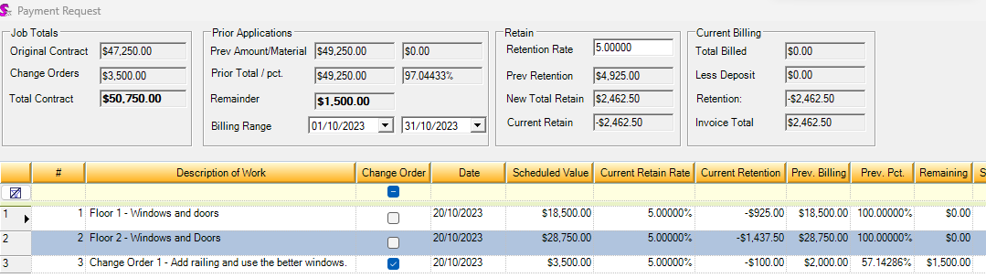
Since retention calculation is always the same, you can see we work out what the retention would have been if the rate was always 5%, then compare to what is stored as a dollar value in the prior billings.
Since now we are in a situation where we billed more than the new total is, that is a positive invoice to allow you to ask for that amount.
You will note the details all now say 5% and we calculate the retention per description of work which rolls up. Retention is always tied to the description of work never the details of it.
Saving this updates a few tables
First the progress payment itself is updated to now state the new rate. We can always use the stored data to work out in the past what it was.
ProgressPaymentID | HeldRetentionRatio | MaxRetentionRate
1444 | 5 | 5

The progress payment detail for this billing shows a positive value in retention now of 2462.5
ProgressPaymentDetailID | ProgressPaymentID | TaskNo | RetentionAmount
3193 | 1444 | 1 | -740
3194 | 1444 | 2 | -4185
3195 | 1444 | 3 | 2462.5

I can use this data to add up everything to how much is left to go and what it would have been on the second or first billing even.
The job control progress tracking tables created for this billing backup as always to the progress payment detail
JobControlProgressTrackingID | JobControlBillingID | ProgressPaymentDetailID | Amount | MaterialAmount | RetentionAmount
4654 | 3332 | 3193 | 7400 | 0 | -740
4655 | 3332 | 3194 | 11100 | 0 | -1110
4656 | 3333 | 3194 | 28750 | 0 | -2875
4657 | 3335 | 3194 | 2000 | 0 | -200
4658 | 3332 | 3195 | 0 | 0 | 925
4659 | 3333 | 3195 | 0 | 0 | 1437.5
4660 | 3335 | 3195 | 0 | 0 | 100

This data lets us know exactly what it is per description of work too, in this specific case Amount is zero because I did not bill for the 1500 railing.

Lowering retention and billing at the same time
Using the exact situation above, instead of just lowering to 5% we also bill the rest of the rail.
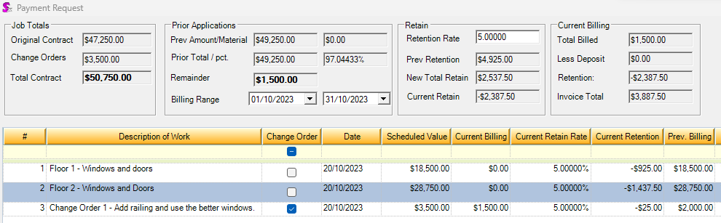
Here you can see the retention being billed is different but the algorithm is the same.
Here we work out 5% of the total prior billing, plus 5% of the new billing less the total retention stored in the database up to that point.
The progress payment detail for this billing shows a positive value in retention now of 2387.5 which is 2462.5 being asked back less the $75 retention being asked for on this billing.
ProgressPaymentDetailID | ProgressPaymentID | TaskNo | RetentionAmount
3193 | 1444 | 1 | -740
3194 | 1444 | 2 | -4185
3195 | 1444 | 3 | 2387.5

The job control progress tracking tables created for this billing backup as always to the progress payment detail
JobControlProgressTrackingID | JobControlBillingID | ProgressPaymentDetailID | Amount | MaterialAmount | RetentionAmount
4654 | 3332 | 3193 | 7400 | 0 | -740
4655 | 3332 | 3194 | 11100 | 0 | -1110
4656 | 3333 | 3194 | 28750 | 0 | -2875
4657 | 3335 | 3194 | 2000 | 0 | -200
4658 | 3332 | 3195 | 0 | 0 | 925
4659 | 3333 | 3195 | 0 | 0 | 1437.5
4660 | 3335 | 3195 | 1500 | 0 | 25

The data is the same as above except the billing amount on the last one is 1500 and the retention is $25 (200 retention before plus asking for 100 back and the 75 being billed)

Detail level
Detail level is reserved for cases where instead of the standard amount for all the lines. This allows one or more descriptions of work to have a different rate independent of the header.
This is not setup in the description of work but in the billing screen.
There are many reasons one would do this and most examples on line do not show this.
For example, you may agree with the customer that retention is not held back on installation services, or change orders are half rate. There are any number of reasons to do this.
Using the example above, let’s say before the last billing, it was negotiated that the railing should not have been held back.
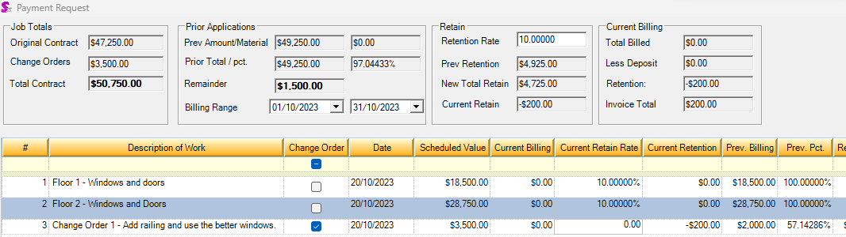
Here I edited the railing (did not actually bill anything but you can certain do so) I set the detail rate to 0.
You can see it knows to ask for 200 as that is the retention before tied to that specific Description of work.
When I save the JobControlBilling record for that line now states 0 in the held retention ratio vs NULL.
Null in that field means use the header which is always deemed current billing for that retention rate.
The job control progress tracking tables created for this billing backup as always to the progress payment detail
JobControlProgressTrackingID | JobControlBillingID | ProgressPaymentDetailID | Amount | MaterialAmount | RetentionAmount
4654 | 3332 | 3193 | 7400 | 0 | -740
4655 | 3332 | 3194 | 11100 | 0 | -1110
4656 | 3333 | 3194 | 28750 | 0 | -2875
4657 | 3335 | 3194 | 2000 | 0 | -200
4660 | 3335 | 3195 | 0 | 0 | 200

Final Retention billing
Eventually you have to get all retention back and it can be at the end of the job when all else is billed or at some point before that. It is all between the person doing the billings and what the customer being billed agrees to.
All that has to be done is simply say retention rate is zero. All jobs eventually end up here.
Using the example above where we asked for 50% back and billed the job, that invoice would look like this
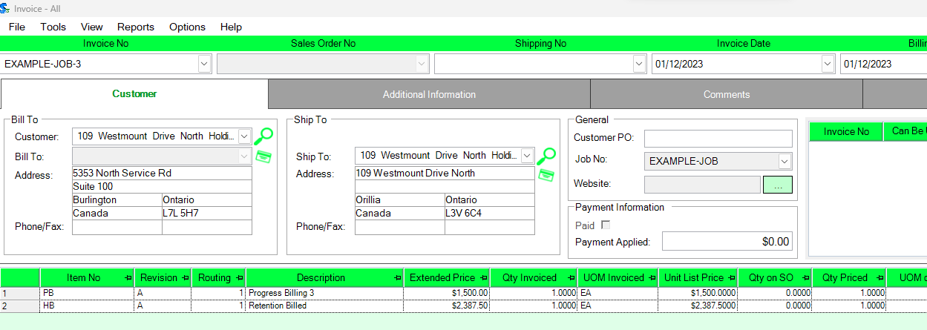
You can predict using the data that the final retention must be a billing asking for 2537.50 as this example pasting into excel proves.
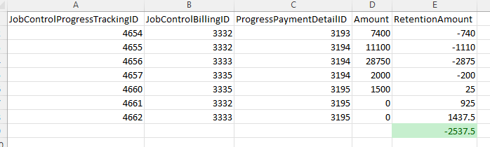
The billing screen backs this up, setting the retention to 0 just goes off all the stored data on all prior billings.
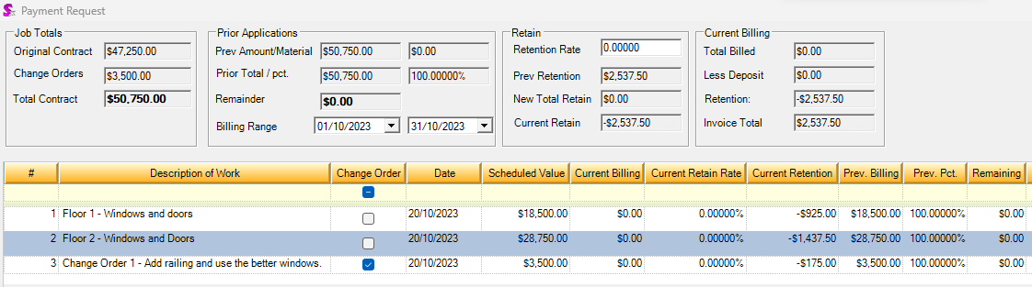
And the invoice now is pure retention, in this case I simulated the end customer agreeing to pay for it a week after the last invoice.
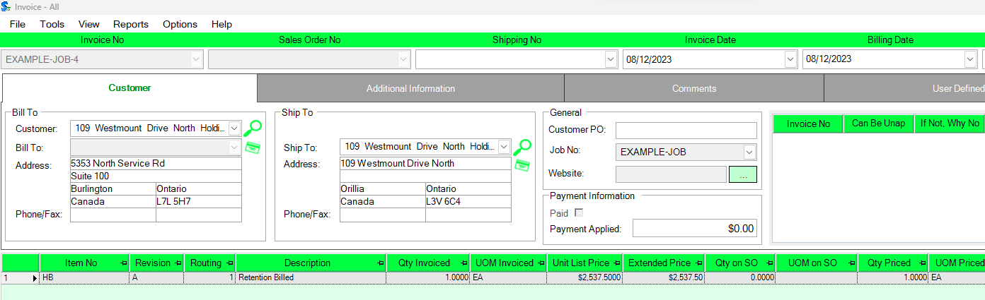
And now the job is done as every dollar is accounted for. There is no rule that says you can reopen the job. I have seen cases where the job was done and months later the customer comes back and asks for more. That could be a new job but as long as everyone agrees it is fine. Some jobs can take months to fully bill out.
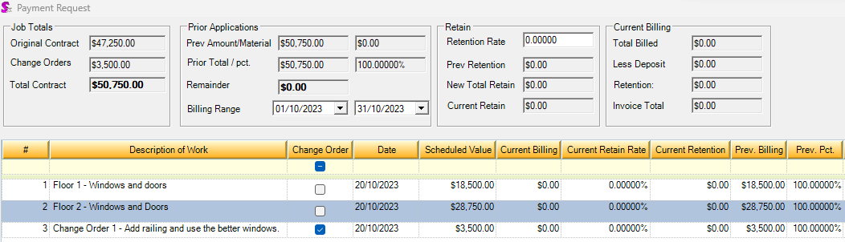

Accounting implications
One of the rules is all billing eventually has to add up to exactly the original contract and change orders (pre tax).
Further more the end customer only pays these kinds of invoices and negative billing is supported and is not a credit note but a negative invoice. To accounting these are the same thing.
Some customers of ours treat these as sales thus unlike deposits are not in a balance sheet account except retention. You can argue that the amount billed is revenue and the hold back is just the customer on the receiving end not paying the full amount.
Unlike deposits which may or may not be taxed based on the situation, these are almost always taxed.
When users actually ship the goods and invoice those, core deposit invoice logic kicks in and ideally the invoice is zero.
Typcially one either bills exactly what was shipped and uses the detail level to figure it out, or bills a bit more than the real value as they just use a whole percentage.
Some of the customers use the idea of a billing order which is not real items and “invoices” that one at the very end with the real product being zero dollar.
As far as the GL to use, some use normal sales, some use a different Gl than the real invoices so they can track billed vs delivered against the Job and you can even use non income statement Gl on the progress invoices and track things that way.
If you end up with a real invoice for the shipment that is more than the total billing, you have to deal with it as the end customer will not pay these. It is best to think of the shipping invoices as internal documents here.
Some I have seen inject an item to denote the shortfall on the GL and handle it.
But the main thing to know is from an AR standpoint, all aging reports and statements and payment logic just sees these invoices generated from the billing module as any other invoice.

